**Practical 05**

**Aim: Write a Python Program to demonstrate different types of exception handing.**

**Errors in Python programming:**

* A program might produce an expected output or no output at all. These situations arise due to the presence of errors in the source code of the program.
* Anything that breaks the normal flow of program is called an error.

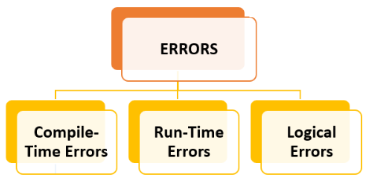

**Compile-Time Errors:**

* A compile-time error generally refers to the errors that correspond to the semantics or syntax.

**Run-Time Errors:**

* A runtime error refers to the error that we encounter during the code execution during runtime.

**Logical Errors:**

* Logical errors – also called semantic errors, logical errors cause the program to behave incorrectly, but they do not usually crash the program. Unlike a program with syntax errors, a program with logic errors can be run, but it does not operate as intended.

**Exceptions:**

* An exception is an event, which occurs during the execution of a program that disrupts the normal flow of the program's instructions.
* In general, when a Python script encounters a situation that it cannot cope with, it raises an exception. An exception is a Python object that represents an error.

**Exception Handling:**

* The try: block contains one or more statements which are likely to encounter an exception.
* If the statements in this block are executed without an exception, the subsequent except: block is skipped.
* If the exception does occur, the program flow is transferred to the except: block.
* The statements in the except: block are meant to handle the cause of the exception appropriately. For example, returning an appropriate error message.